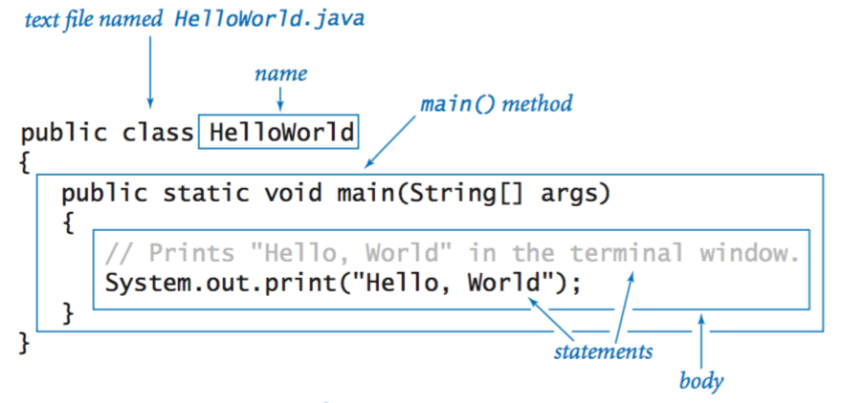Example of how to format a simple java code:

**Data types:**

|  |  |  |
| --- | --- | --- |
| **TYPE** | **SET OF VALUES** | **COMMON OPERATORS** |
| int | Integers | +, -, *, /, % |
| double | Floating-point numbers (decimals, etc.) | +, -, *, / |
| boolean | Boolean values | &&, ||, ! |
| char | characters |  |
| String | Sequence of characters (text) | + |

**Declaration and assignment statements:**

* Can be used when assigning variables, etc.

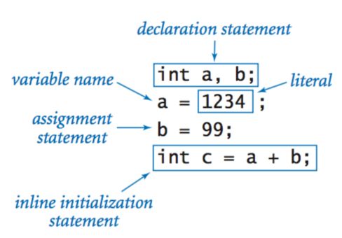

**Integers:**

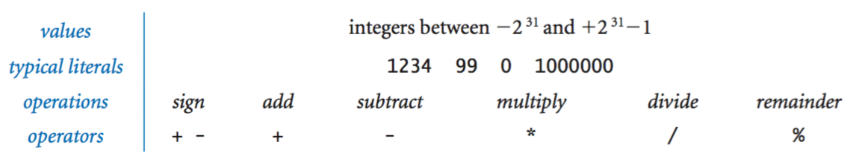

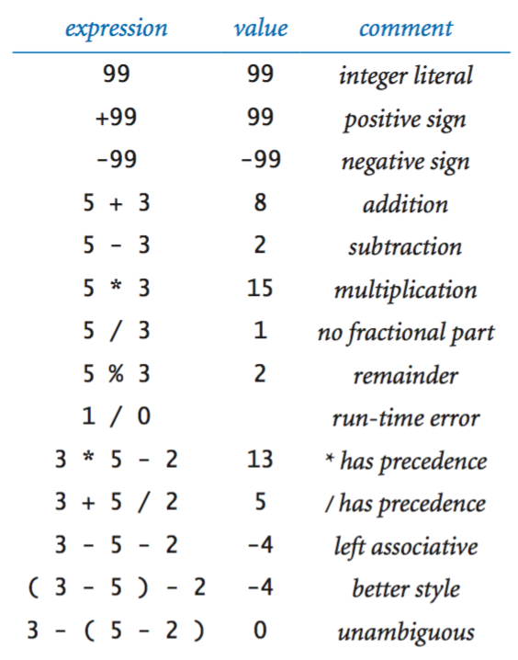

**Floating-point Numbers:** 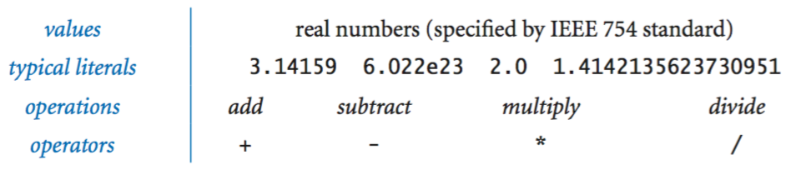

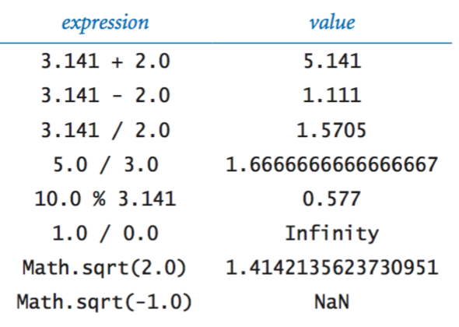

**Booleans:**

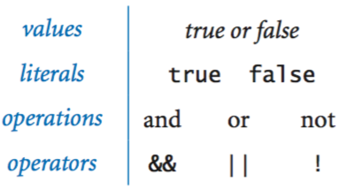

**Comparison Operators:**

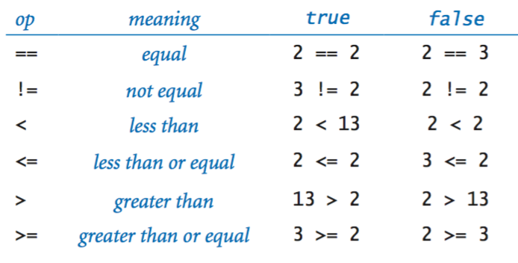

**Printing:**

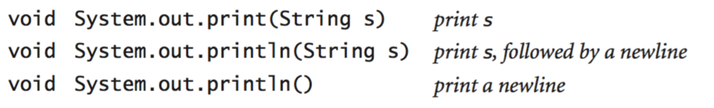

**To convert a variable to a different type of value:**

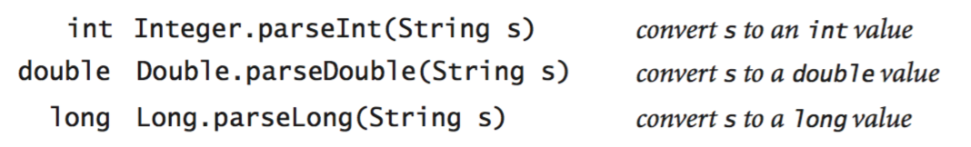

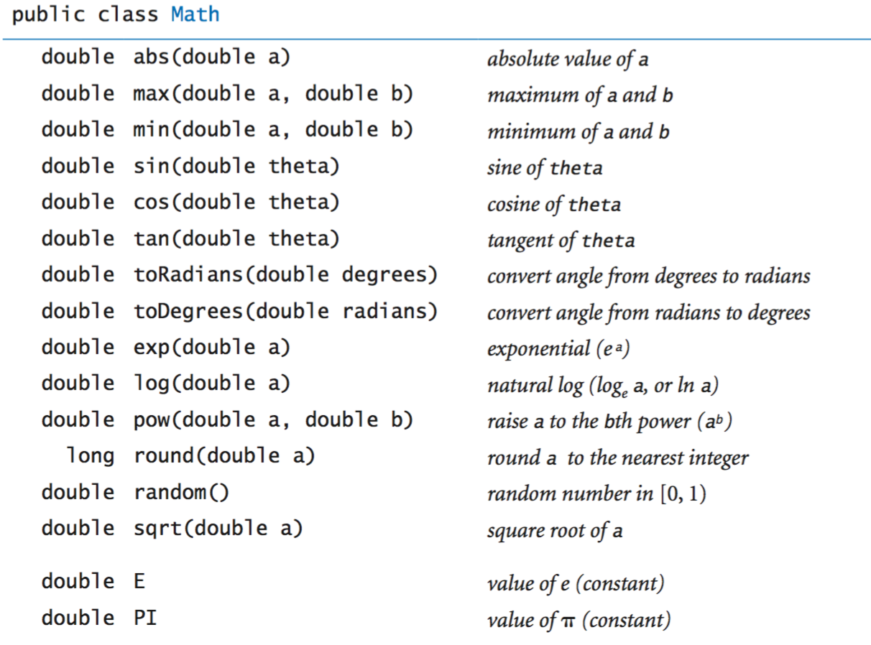**Math:**

**Java Library Calls:**

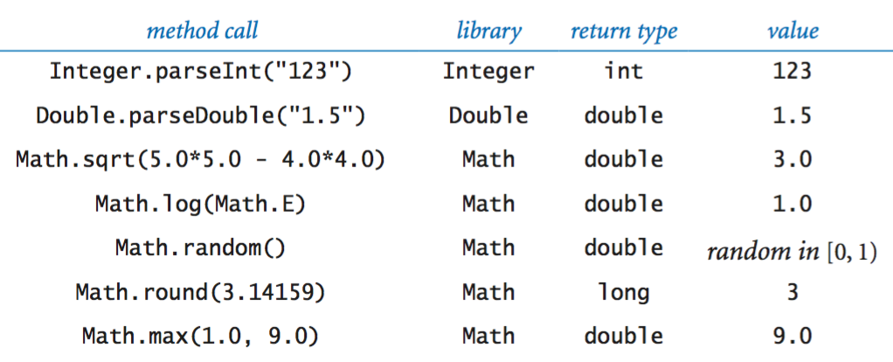

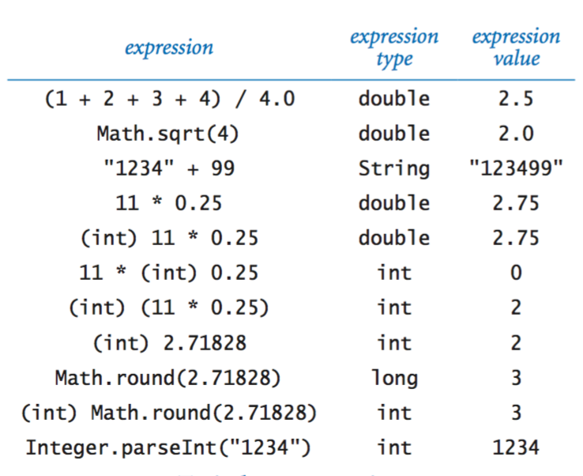**Type Conversion:**

**If statements:**

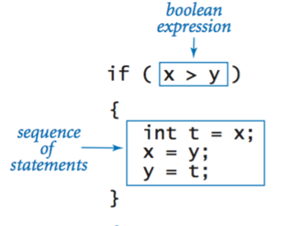

**If and if-else statements:**

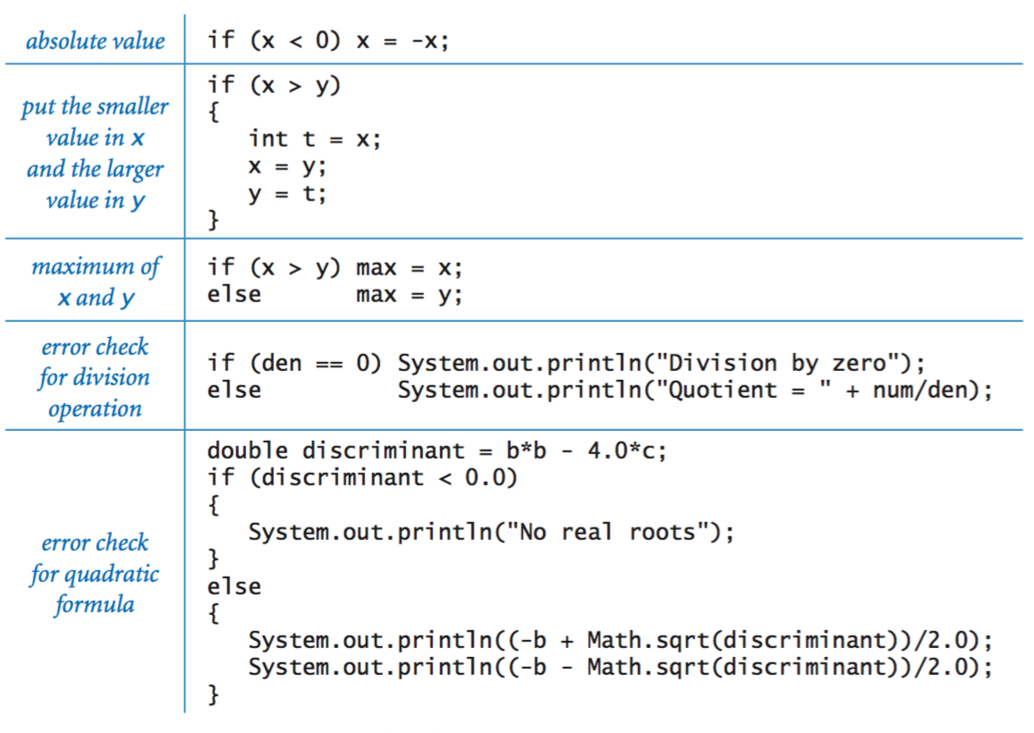

**While Loops:**

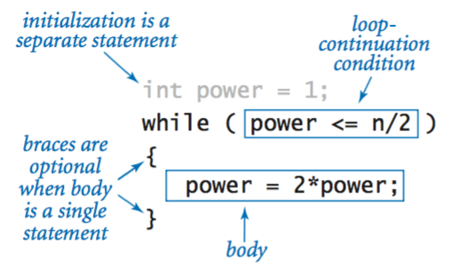

**For Loops:**

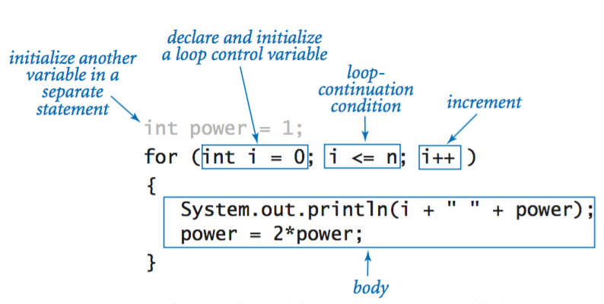

**Loops:** 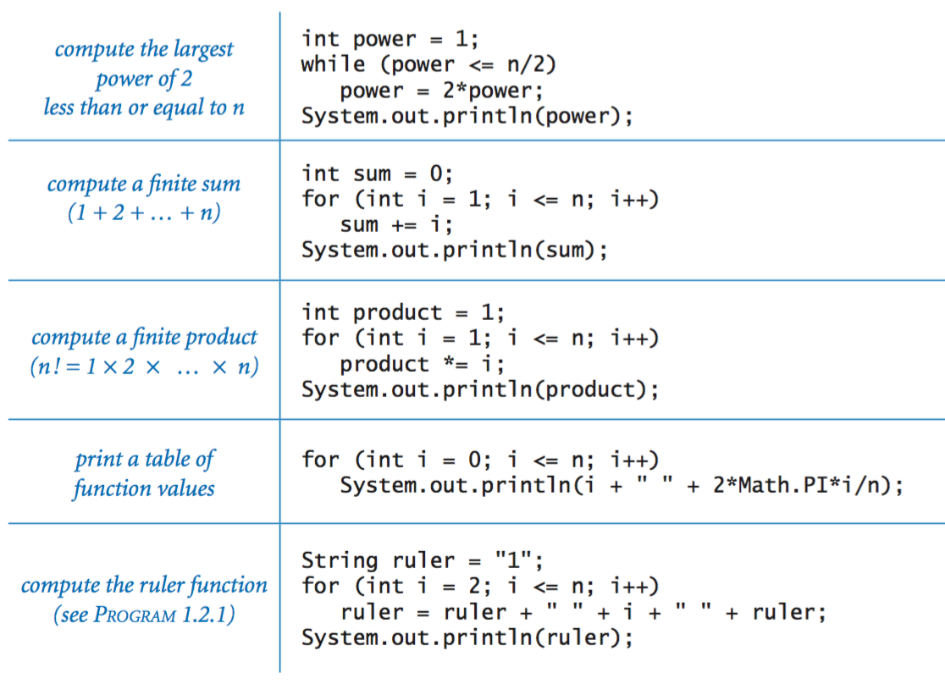

**Break statements** (it is for terminating a loop and going onto the next statement after the loop)**:**

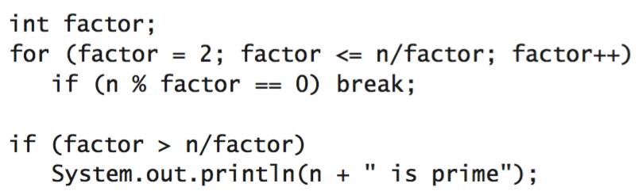

**Do-while loop:**

* do something only with specific requirement (the while)

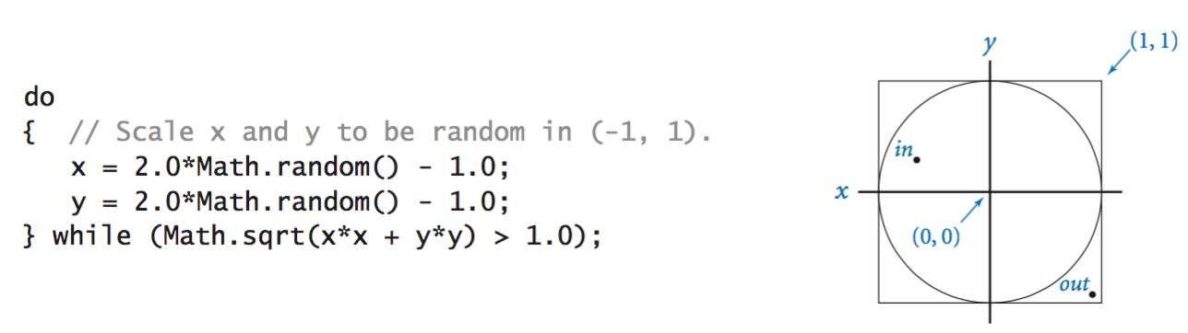

**Arrays:**

* for storing a number of elements of the same type
* storing data

**Switch statement.**

* 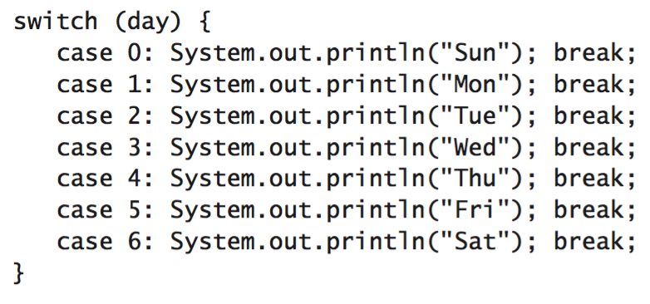

**Arrays**

* 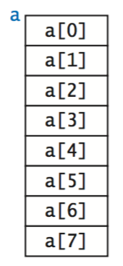

Inline array initialization.

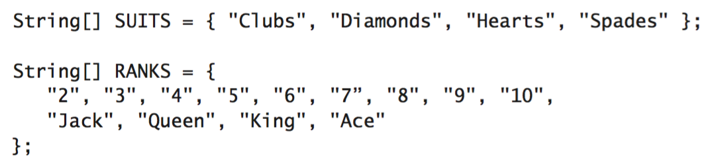

Typical array-processing code.

* 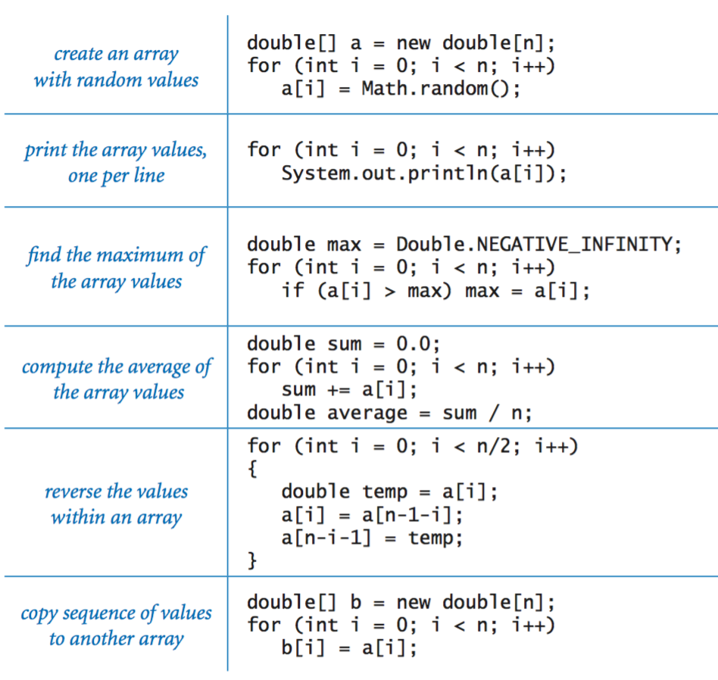

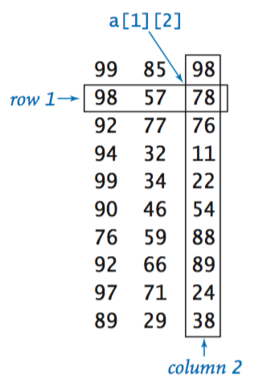**Two-dimensional arrays.**

Inline initialization.

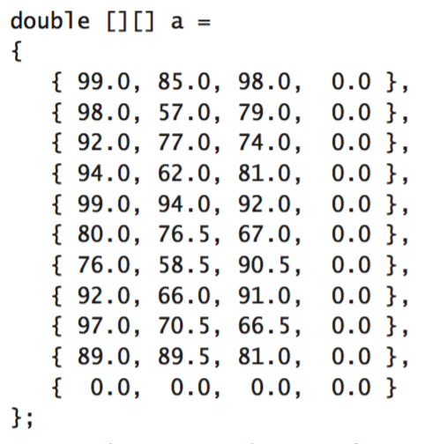

**Our standard output library.**

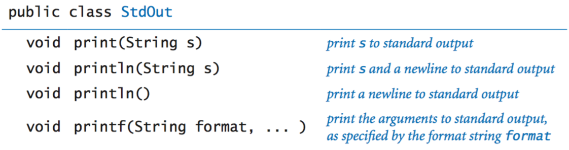

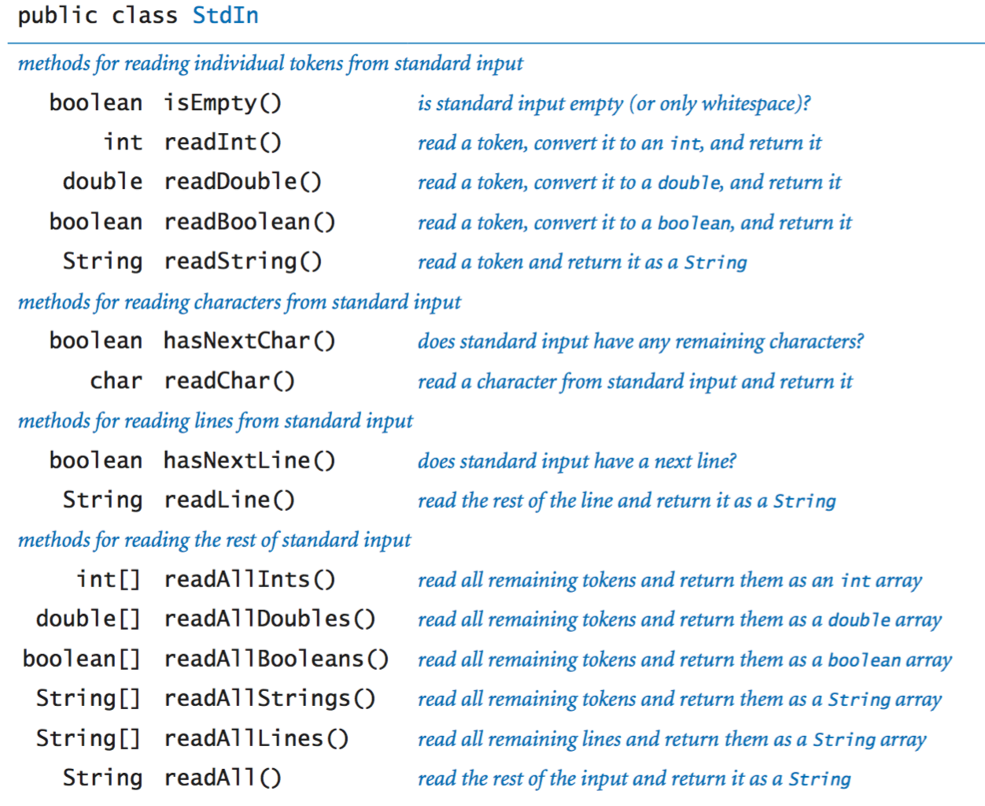**Our standard input library.**

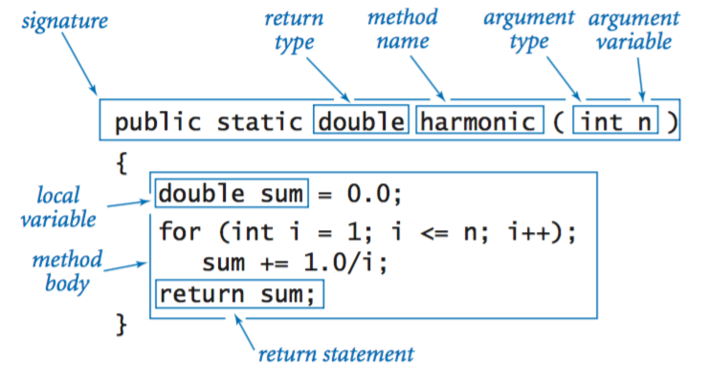**Functions.**

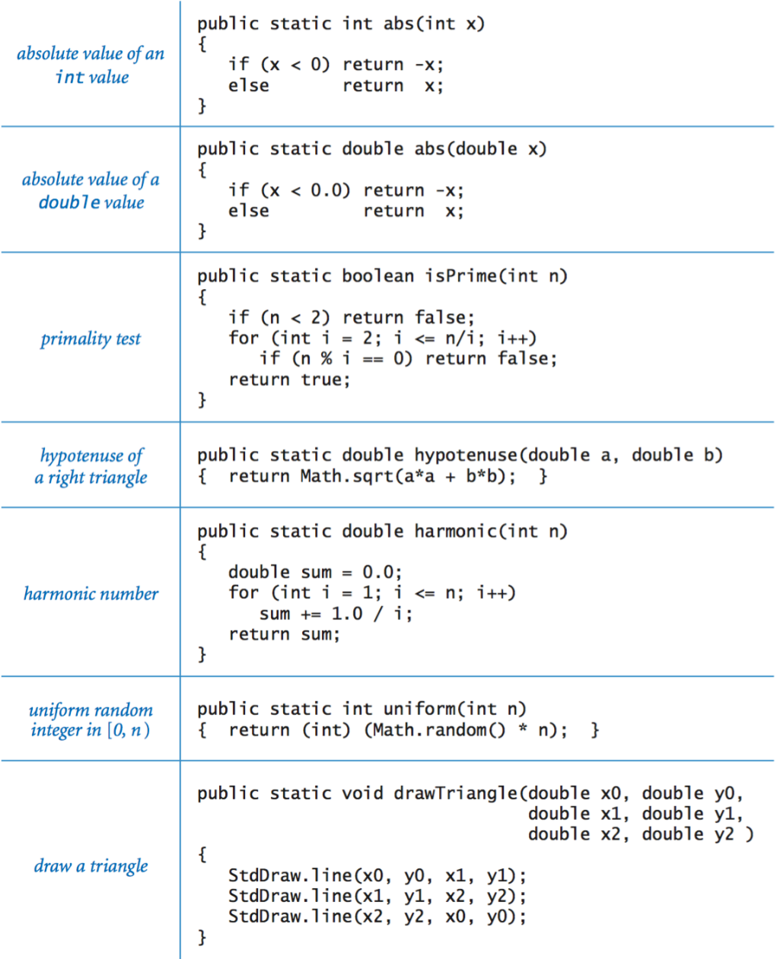

**Constructors.**

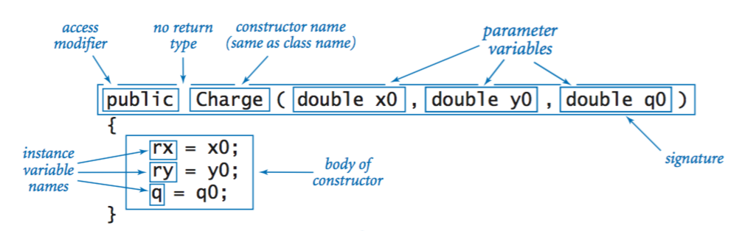

**Instance methods.**

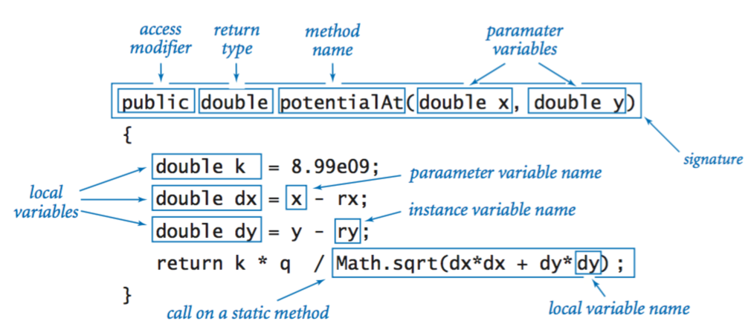

**Classes.**

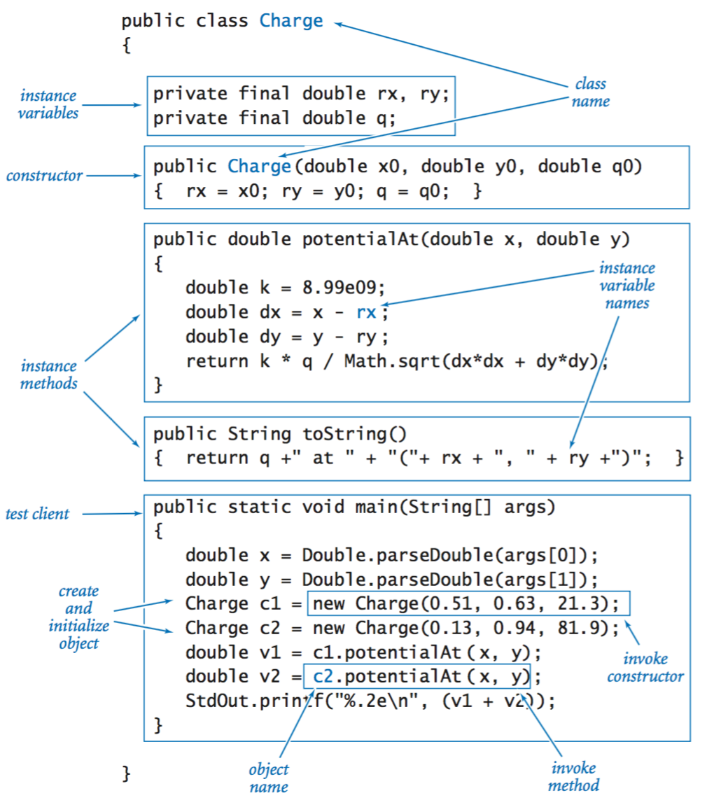

**Java's String data type.**

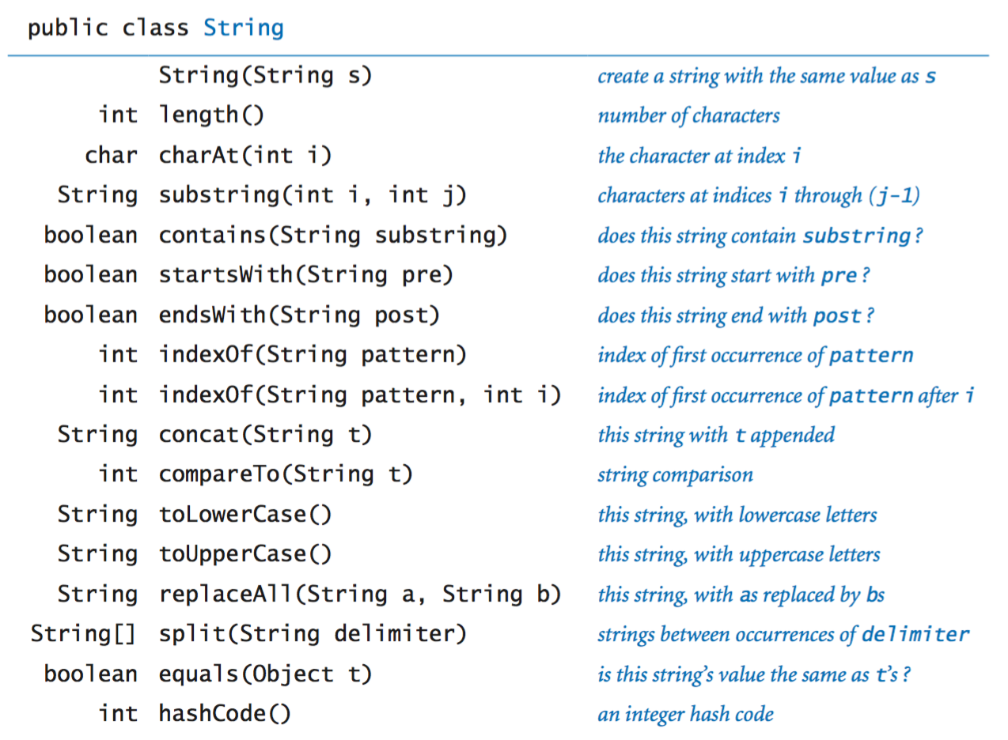

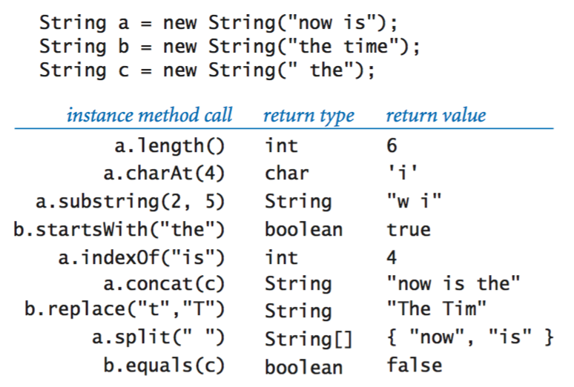

**Our input library.**

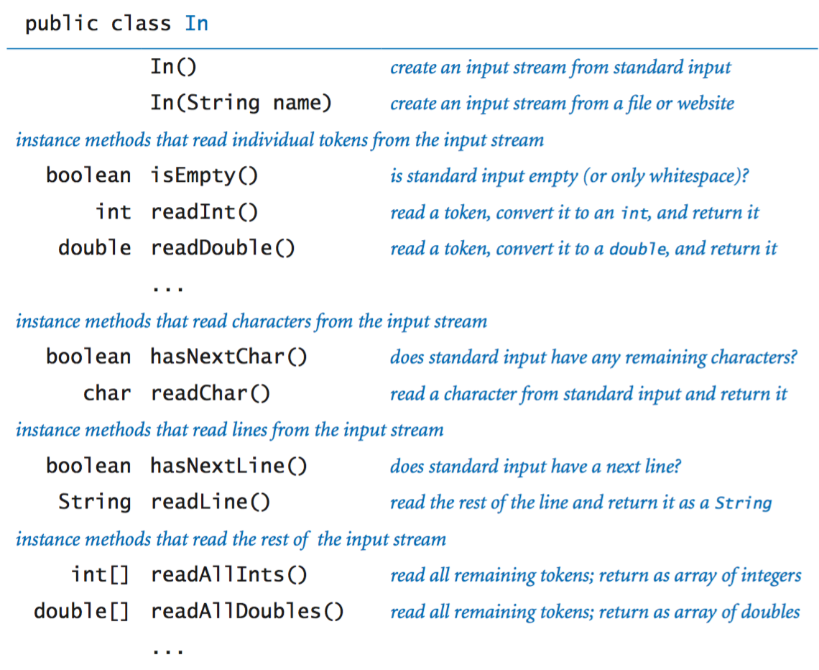

**Our output library.**

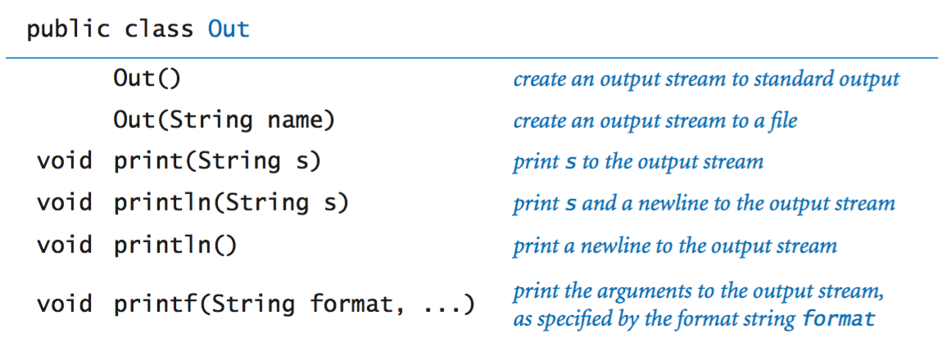

**Our stack data type.**

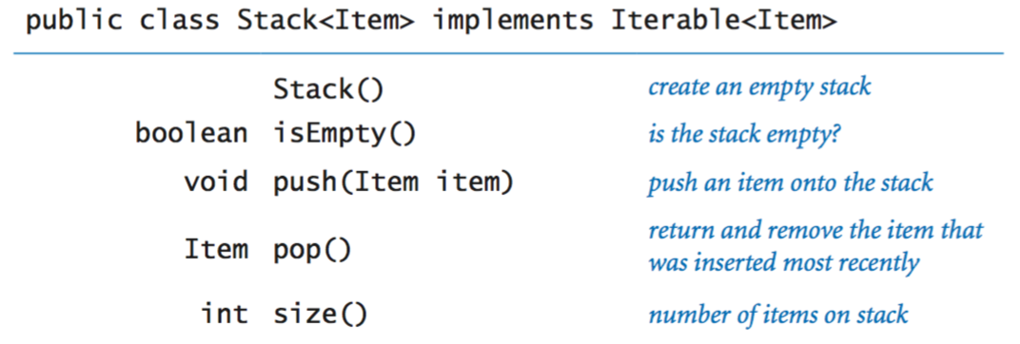

**Our queue data type.**

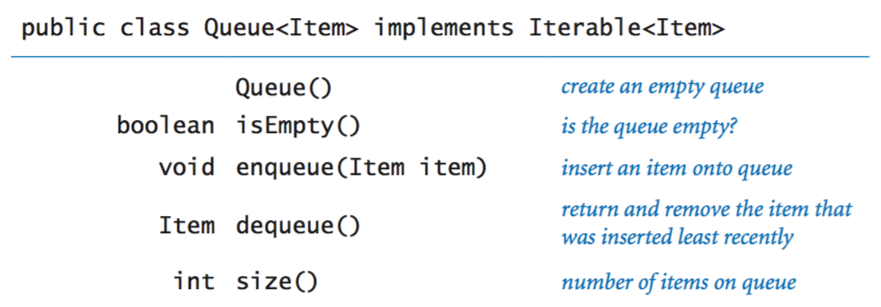

Also, pi is PI in java (if I ever need it)